

**Tribhuvan University**

**Faculty of Humanities and Social Sciences**

An Internship Report

ON

**Front-end**

AT

CubixTech Nepal

Submitted to

Department of Computer Application

Janjyoti Multiple Campus

Mahendranagar, Kanchanpur

***In partial fulfillment of the requirements for the Bachelors in Computer Application***

Submitted by

Puja Bam (4040453)

Under the Supervision of

Puneet Ayer

Dec 9, 2022



**Tribhuwan University**

**Faculty of Humanities and Social Science**

**Janjyoti Multiple Campus**

**Supervisor’s Recommendation**

I hereby recommend that this internship project report be prepared under my supervision by Puja Bam entitled **“Student Management System**” is satisfactory in partial fulfillment of the requirements for the degree of Bachelor of Computer Application is recommended for the final evaluation.

…………………………

Department of Humanities and Social Science

Janjyoti Multiple Campus



**Tribhuwan University**

**Faculty of Humanities and Social Science**

**Janjyoti Multiple Campus**

# LETTER OF APPROVAL

This is to certify that this internship project prepared by Puja Bam entitled **“Student Management System”** in partial fulfillment of the requirements for the degree of Bachelor in Computer Application has been evaluated. In my opinion it is satisfactory in the scope and quantity as a project for the required degree.

|  |  |
| --- | --- |
| ………………………  Department of Humanities and Social Science  Janjyoti Multiple Campus, Bhansi  Mahendranagar, Kanchanpur | ………………………….  Department of Humanities and Social Science  Janjyoti Multiple Campus, Bhansi  Mahendranagar, Kanchanpur |
| .......................................  **Internal Examiner** | ………………………  **External Examiner** |

# ACKNOWLEDGEMENT

This internship period has been a very great learning experience for me as it has given me the chance to understand how things are done outside the classroom. I have learned a lot about project execution in the real world and my interpersonal skills and self-confidence have improved significantly. This internship project on Student Management System has helped me in my transition phase from a student to professional. Thus, the vote of thanks goes to all people who are directly or indirectly involved in this project. First and for most I would like to express my sincere gratitude towards Janjyoti Multiple Campus and Tribhuvan University for giving a course like Bachelors of Computer Application (BCA) and providing the opportunity to work as an intern in the organization. I would like to extend my gratitude to Prakash Datt Bhatt for providing necessary support and guidance. I would like to extend my gratitude to Erasoft Solution Pvt. Ltd. for selecting me as an intern and for their assistant and support throughout my internship period. I would like to express my sincere thanks to Mr. Om Khadka (Director of Erasoft Solution Pvt. Ltd.) for providing me an opportunity to carry out the internship task in his reputed organization. Lastly, I would like to express my sincere thanks to all the seniors and friends who helped me directly or indirectly during this internship period. Sincerely,

Puja Bam(4040453)

# ABSTRACT

In this .net article we will discuss student management system software which is used in accurate, efficient information in less time. Our main focus in this student software to keep student record, faculty, marks record, record of examination record, record of student/faculty details, student record insert, update , delete. In this student management software only owner or administrator can operate the system. The next work is to create student profile with suitable course. After adding course detail and teacher detail we can add student detail in our system. We provide search facility by course wise, student wise, teacher wise in our project. This student management software is useful for saving valuable time and reduces the huge paper work.

**Table of Contents**

LETTER OF APPROVAL v

ACKNOWLEDGEMENT vi

ABSTRACT vii

LIST OF ABBREVIATION ix

LIST OF TABLES x

LIST OF FIGURE xi

Chapter 1: INTRODUCTION 1

1.1. Introduction 1

1.2. Problem Statement 1

1.3. Objective 2

1.2. Scope and Limitation 2

1.5. Report Organization 3

Chapter 2: INTRODUTION TO ORGANIZATION 4

2.1. Organization Details 4

2.2. Organizational Hierarchy 5

2.3. Working Domains of Organization 5

2.4. Description of Intern Department 6

Chapter 3: BACKGROUND STUDY AND LITERATURE REVIEW 7

3.1. Background Study 7

3.2. Literature Review 7

Chapter 4: INTERNSHIP ACTIVITIES 9

4.1. Roles and Responsibilities 9

4.2. Weekly log 9

4.3. Description of the Project(s) Involved During Interns 14

4.4. Tasks / Activities Performed 15

Chapter 5: CONCLUSION AND LEARNING OUTCOMES 16

5.1. Conclusion 16

5.2. Learning Outcomes 16

References 17

Appendices 18

# LIST OF ABBREVIATION

|  |  |
| --- | --- |
| AJAX | Asynchronous JavaScript and XML |
| URL |  |
|  |  |
|  |  |
|  |  |
|  |  |
|  |  |

# LIST OF TABLES

Table 4.2.1 Weekly Log…………………………………………………………………...9

Table 4.2.2 Weekly Log………………………………………………………………….10

Table 4.2.3Weekly Log………………………………………………………………….10

Table 4.2.4 Weekly Log………………………………………………………………….11

Table 4.2.5 Weekly Log………………………………………………………………….11

Table 4.2.6 Weekly Log………………………………………………………………….12

Table 4.2.7 Weekly Log………………………………………………………………….12

Table 4.2.8 Weekly Log………………………………………………………………….13

# LIST OF FIGURE

Fig: 2.2. Organizational Hierarchy………………………………………………………5

# Chapter 1: INTRODUCTION

## 1.1. Introduction

This project on “Student Management System” is useful for easy user interface. The system utilizes the powerful database management, data retrieval and data manipulation. This project provides more ease for managing the data than manually maintaining in the documents. The project is useful for saving valuable time and reduces the huge paper. It will help educational Institutions like schools and colleges will keep track of their student records like personal details, contact details, marks details, etc. The Internet repaid becoming a part of the everyday lives of a majority of people in the world. People perform various activities on the Internet and one of them is storing their data in data-base where they are interested in. In these data base’s they can post the queries and they can retrieve the required data. Obviously, there is a need of Student Information System software for management of student’s data. There are many departments of administration for the maintenance of college information and student databases in any institution. All these departments provide various records regarding students.

Most of these track records need to maintain information about the students. This information could be the general details like student name, address, performance, attendance or specific information related to departments like collection of data. All the modules in college administration are interdependent. They are maintained manually So they need to be automated and centralized as, Information from one module will be needed by other modules For example, when a student needs his course completion certificate it needs to check many details about the student like his name, registration number, year of study, exams he attended and many other details. So, it needs to contact all the modules that are office, department and examination and result of students.

## 1.2. Problem Statement

* The common issue faced by student management in educational institutions is the data loss, manual monitoring of students’ performance and etc.
* These activities create loads of tasks to be done by the educators and school administrators. Their records were also prone to losses due to a lack of security.
* There are still a lot of problems to be discussed but we only highlighted the major ones.
* Solution: The main purpose of the Student Management System is to track profiles, courses, logins and marks. It keeps track of all records, student, teacher, and profile-related information.
* Student management systems make it easier for professors to retrieve and sort information, which makes their jobs easier.
* Professors and student supervisors can use this method to keep track of their students’ involvement.
* These objectives foster, support, and sustain an atmosphere inside educational institutions that promotes, supports, and sustains effective teaching and learning.

## 1.3. Objective

This document provides the technical description of all software requirements of STUDENT MANAGEMENT SYSTEM. The document will not only define the product functions, user characteristics, constraints, and specific requirements of the system, but also serve as a basis for the Software Design Document that is prepared according to IEEE Std. The objective of the software is to maintain information pertaining to the students with the purpose of:-

* Planned approach towards working
* Accuracy
* Reliability
* No Redundancy
* Immediate retrieval of information
* Immediate storage of information
* Easy to operate

## 1.2. Scope and Limitation

**Scope of the SMS**

“STUDENT MANAGEMENT SYSTEM” is a project with a mission of viewing and manipulating student information of COLLEGE in a Web-based environment. Thus, the overall system will consist of a Student Database System and Web Interface. The Student Database System will supply the fundamental database structure of the entire system whereas Web Interface will provide a secure Web interface between the users and the database. The Software aims to create a “paperless office” rather than using a traditional record keeping system. Although this project is presently being designed specifically for 3 Integral Institute of Medical Sciences and Research but there exists the possibility in future to upgrade it to general level. The software will not only help the following levels of user in viewing the information but also each user can alongside update changes within their respective access limits.

* Administrative Level
* User Level
* Management of Institute
* Faculty
* Students
* Department Staff

**Limitations of the SMS**

The system does not cover the computation of student class scheduling, viewing of subjects and paying of fees. Not accepting any online payments. It can only operate for Admin of the College. Student can’t access & operate the system.

## 1.5. Report Organization

This report document contains five chapters including this chapter and it is also contains the cover page, Certificate page, letter of approvals, Acknowledgement, abstract and references. The chapter one contains basic introduction of the developed application, its problem statement, objectives of the application, Scope and Limitation of SMS. Chapter two defines and describes Organizational details and hierarchy of working domains and it contains description of intern Department. Chapter three presents background study, general concepts and terminologies related to this present project. In Chapter four it can exposes internship activities like roles and responsibilities, weekly log and project involved during the internship. In chapter five here we describes the conclusion of the given project and what we gain the outcome of this project.

# Chapter 2: INTRODUTION TO ORGANIZATION

## 2.1. Organization Details

Originally established as a software development house in Nepal in 2008 as ERASOFT Pvt. Ltd, by founder Kabita Raya, the company encountered an organic growth under the leadership of Managing Director Om Khadka, in the sector of software and mobile application development beyond its foundation expertise. As the year passed, the expansion process continued towards broader and holistic engagement by rooting its steam to the company’s mission, vision and value which hinges on the technology evolution and innovation. From the software development of ERP/EMIS the entity moved on to web application development, library management in Nepal, business ERP, IT consultancy, training services, and library consultancy. Erasoft has strong presence on national market and is looking forward to establishing alliance in the international market. Known as the best software development company in Nepal, we solely focus on providing on time and professional service. Like most international Technology Company, Erasoft understands that technology has become a permanent feature, so we work as your partner to deliver smart technology solutions that align with your business needs. Till date we have supported Government & Non-Government organization, education sector, and other existing corporate business inside Nepal by developing campus management software, learning management software, school management software, web application and mobile application supporting their needs. During the serving period, we have identified that our trusted and capable network of partners and clients has no doubt’s unpinned on our success. We clearly understand that every project has clearly defined business goals, so it is important for Erasoft to measure the return on investment (ROI) of clients. The key to our success is to commitment to progressive improvement over short span achievement. [1]

Some of the services provided by the organization are;

* Web based Application
* ERP Solution
* Software Development
* Library Consultancy
* IT consultancy
* IT Training
* Annual Maintenance Services [2]

## 2.2. Organizational Hierarchy

Organization hierarchy is the order of members based on authority. It refers to the ranks from entry-level employees to senior managers or executives. Organization hierarchies typically consist of multiple levels, and members with more authority occupy higher positions.

**Director of Company**

The Sales Department Staffs

Head of the project

Department

Head of the Software Engineers

Head of the Organization and Management

Head of the Customer Support

Head of the Department

Software Engineers

Office Staffs

Consultants

Head of the Project

Project Analysts

**Fig: 2.2. Organizational Hierarchy**

## 2.3. Working Domains of Organization

Conventionally, domain is defined as the technology employed, population served and services rendered by an organization. Erasoft Solution Private Limited offers From the software development of ERP/EMIS the entity moved on to web application development, library management, business ERP, IT consultancy, training services, and consulting services to businesses, assisting them in accelerating the adoption of new technologies, resolving complex issues that arise frequently as a result of digital evolution, and coordinating ongoing innovation. The Company mainly focused on strategic IT consulting, Mobile and Web Development, UX Designing, Logo Design and Branding.

## 2.4. Description of Intern Department

Erasoft Solution Pvt. Ltd. is one of the most relevant Companies in the Nation which is established in 2008 and provides continuous facilities in the Educational Era. EraSoft Solution provides Internships for all students who are applicable and enthusiastic about their careers.

Interns develop the system as part of the Design and Development team. There are two interns working for the department in total. The intern's field of work is determined by the intern's interests as well as the organization's needs. According to their line of employment, interns are paired with the appropriate supervisor. As a result, the interns are overseen and monitored by the company's senior developers in order to perform the daily tasks that they are allocated. To complete the assignment provided by their supervisor, the interns must perform successfully

While doing the Internship at this Company All Staffs of the company were Friendly and the Ambience was respectable. From this Company, Students progress Practical and Marketing Skills for their careers which will be helpful in upcoming future.During the Internship period, all the activities are done under the observation of Managing Director Mr. Om Khadka who is a passionate and supportive person.

# Chapter 3: BACKGROUND STUDY AND LITERATURE REVIEW

## 3.1. Background Study

**Fundamental Theories**

Student Management System is software which is helpful for students as well as the school authorities. In the current system all the activities are done manually. It is very time consuming and costly. [3]

A student management system can mean several different things. However, context clues give away that this software is for managing students. But handling students can mean many things. So what really is a student management system?

A Student Management System is also known as a Student Information System (SIS).These systems work to coordinate scheduling and communications between faculty regarding students. This system exists to simplify information tracking for both parents and administrative staffs. [4]

There are certain works that are beyond human capacities which can be carried out through automation techniques. Library Automation System of the University of Toronto in 1963-1972 was one of the first achievements to manage the data with the help of automated system. The real idea of implementing Automation is to enhance efficiency, reduce delays, increase production flexibility, reduce prices, human error elimination, and alleviate labor shortage, high degree of accuracy. There are certain activities restricted to specific users so to avoid the violation of code of conduct fairness is maintained in the system. Thus, the new system is named as the student management system. Vol-7 Issue-3 2021 IJARIIE-ISSN(O)-2395-4396 14484 www.ijariie.com 1793 The prevailing offline paper based system has several disadvantages such as excessive use of time for manual record keeping, wasting resources, inefficiency in data logging as inconsistent data can be recorded

## 3.2. Literature Review

Literature was reviewed from various sources, like from research papers, publications books, existing bibliographic information, and recommendations by the project panel. These research papers has provided us sufficient amount of data for the survey. Automation can be defined as the process of reducing or minimal zing the manual hard work with help of computers, computer operated software and devices.

A student information system provides a simple interface for the easy collation and maintenance of all manner of student information. The creation and management of accurate, up-to-date information regarding students’ academic careers is critical students and for the faculties and administration of Sebha University in Libya and for any other educational institution. A student information system deals with all kinds of data from enrollment to graduation, including program of study, attendance record, payment of fees and examination results to name but a few. All these data need to be made available through a secure, online interface embedded in university’s website. [5]

# Chapter 4: INTERNSHIP ACTIVITIES

## 4.1. Roles and Responsibilities

During the internship period knowledge of various platforms and programming languages  
are gained. My responsibility was the Back-end developer. The database of this system is  
contact from MySQL to Microsoft SQL Server Management System.

## 4.2. Weekly log

**Table** **4.2.1 Weekly log**

|  |  |  |  |
| --- | --- | --- | --- |
|  | **DATE** | **DAY** | **NAME OF THE TOPIC/MODULE COMPLETED** |
|  | Sep 18 2022 | Sunday | Introduction of .NET frame work |
|  | Sep 19 2022 | Monday | Features of .NET {IDE, CLR} |
| 1st week | Sep 20 2022 | Tuesday | Continuing the .NET features |
|  | Sep 21 2022 | Wednesday | Introduction of VB.NET |
|  | Sep 22 2022 | Thursday | Introduction of tools |
|  | Sep 23 2022 | Friday | Introduction of properties |

**Table** **4.2.2 Weekly log**

|  |  |  |  |
| --- | --- | --- | --- |
|  | **DATE** | **DAY** | **NAME OF THE TOPIC/MODULE COMPLETED** |
|  | Sep 25 2022 | Sunday | Introduction to web application |
|  | Sep 26 2022 | Monday | Understanding controls like [label, button] etc., |
| 2nd week | Sep 27 2022 | Tuesday | Continuing understanding controls |
|  | Sep 28 2022 | Wednesday | Introduction to windows services |
|  | Sep 29 2022 | Thursday | Continuing windows services |
|  | Sep 30 2022 | Friday | Introduction to class libraries |
| **Table** **4.2.3 Weekly log** | | | |
|  | **DATE** | **DAY** | **NAME OF THE TOPIC/MODULE COMPLETED** |
|  | Oct 9 2022 | Sunday | Introduction .NET REMOTING |
|  | Oct 10 2022 | Monday | Introduction to Web Programming |
| 3rd week | Oct 11 2022 | Tuesday | Understanding web request, web clients, web servers |
|  | Oct 12 2022 | Wednesday | Understanding web application v/s windows application |
|  | Oct 13 2022 | Thursday | Introduction to html |
|  | Oct 14 2022 | Friday | Continuing html |

**Table** **4.2.4 Weekly log**

|  |  |  |  |
| --- | --- | --- | --- |
|  | **DATE** | **DAY** | **NAME OF THE TOPIC/MODULE COMPLETED** |
|  | Oct 16 2022 | Sunday | Understanding Design code/ Source code |
|  | Oct 17 2022 | Monday | Continuing Design code and Source code |
| 4th week | Oct 18 2022 | Tuesday | Understand menus and Master page |
|  | Oct 19 2022 | Wednesday | Continuing menus and master page |
|  | Oct 20 2022 | Thursday | Create simple basic Arithmetic programs |
|  | Oct 21 2022 | Friday | Continuing basic programs |

**Table** **4.2.5 Weekly log**

|  |  |  |  |
| --- | --- | --- | --- |
|  | **DATE** | **DAY** | **NAME OF THE TOPIC/MODULE COMPLETED** |
|  | Nov 1 2022 | Tuesday | Introduction to SQL Server 2019 |
|  | Nov 2 2022 | Wednesday | Understanding Database and Tables |
| 5th week | Nov 3 2022 | Thursday | Continuing Database and Tables |
|  | Nov 4 2022 | Friday | Continuing Database and Tables |
|  | Nov 6 2022 | Sunday | Introduction of Dao Database |
|  | Nov 7 2022 | Monday | Understanding of Web Configuration |

**Table** **4.2.6 Weekly log**

|  |  |  |  |
| --- | --- | --- | --- |
|  | **DATE** | **DAY** | **NAME OF THE TOPIC/MODULE COMPLETED** |
|  | Nov 8 2022 | Tuesday | Understanding login and design code |
|  | Nov 9 2022 | Wednesday | Continuing login and design code |
| 6th week | Nov 10 2022 | Thursday | Understanding simple projects |
|  | Nov 11 2022 | Friday | Understanding sql and vb.NET connection |
|  | Nov 13 2022 | Sunday | Continuing sql and Vb.NET connection |
|  | Nov 14 2022 | Monday | Understanding Support unit |

**Table** **4.2.7 Weekly log**

|  |  |  |  |
| --- | --- | --- | --- |
|  | **DATE** | **DAY** | **NAME OF THE TOPIC/MODULE COMPLETED** |
|  | Nov 15 2022 | Tuesday | Understanding classic ASP VS ASP.NET |
|  | Nov 16 2022 | Wednesday | Introduction to ASP.NET web server controls |
| 7th week | Nov 17 2022 | Thursday | Working with different web server controls |
|  | Nov 18 2022 | Friday | Standard controls , validation controls |
|  | Nov 21 2022 | Monday | Introduction to data control in depth |
|  | Nov 22 2022 | Tuesday | Project session |

**Table** **4.2.8 Weekly log**

|  |  |  |  |
| --- | --- | --- | --- |
|  | **DATE** | **DAY** | **NAME OF THE TOPIC/MODULE COMPLETED** |
|  | Nov 23 2022 | Tuesday | Designs and Analysis |
|  | Nov 24 2022 | Wednesday | Continuing Designs and Analysis |
| 8th week | Nov 25 2022 | Thursday | Coding |
|  | Nov 27 2022 | Friday | Continuing Coding |
|  | Nov 28 2022 | Sunday | Testing |
|  | Nov 29 2022 | Monday | Continuing Testing |

There are some Technical Details of Activities which are describes as below.

**Microsoft Framework**

It is a new, easy, and extensive programming platform. It is not a programming language, but it supports several programming languages. By default .NET comes with few programming language including C# (C Sharp), ASP.NET, J# and managed C++. .NET is a common platform for all the supported languages. So, developers need not learn many libraries when they switch to different languages. Only the syntax is different for the various languages.

**Front End: ASP.NET Version 2019 with C#**

ASP.NET is the old version of Microsoft’s Active Pages Technology. ASP.NET is the next generation of ASP. It is a latest technology for server side scripting. It was written from the ground up & is not backward compatible with classic ASP. ASP.NET is the server side scripting technology that enables scripts to be executed by an internet server. ASP stands for Active Server Pages. ASP.NET is the program that runs inside the IIS (Internet Information Services) is a Microsoft Internet server. Microsoft’s first technology ASP.NET was a powerful & flexible programming language. But it was too code oriented. It was not an application framework & not an enterprise development tool. Then 20 the Microsoft.Net framework was developed to solve this problem. ASP.NET combines unprecedented Developer productivity with performance reliability & deployment. It is still easy to grasp for new comers but it also provides many new ways. ASP.NET is a compiled, NET-based environment; you can author applications in any .NET compatible language, including Visual Basic .NET, C# and JavaScript.NET. Additionally, the entire .NET Framework is available to any ASP.NET application. Developers can easily access the benefits of these technologies, which include the managed common language runtime environment, type safety, inheritance and so on. Back End SQL server 2019 is a full featured relational database management system that offers a variety of administrative tools to easy the burdens of database development & administration. Enterprises manager is the main administrative console for sql server installation. We can perform high level administrative function that affects one or more servers, schedule common maintenance tasks or create & modify the structure of individual database. Query analyzer offers s quick & dirty method for performing query against sql server database. SQL profiler provides a window into inner working of our database. Server manager is used to MY-SQL servers. Data transformation services provide extremely data between a Microsoft sql server installation & large variety6 of other formats.

## 4.3. Description of the Project(s) Involved During Interns

Mitra ERP/EMIS is an Education Management Information System, a digital process taken up the higher secondary college & universities such as Tribhuvan University, Pokhara University for the QAA certification in order to get the Government Grant provided by the University Grants Commission (UGC). Erasoft provides Mitra ERP/ EMIS solutions to private college, public campus/ universities to attain QAA.

The prime goals of the Website Design are shown below.

1. To create a visually attractive and effective website that would take less time to  
   maintain, be more user-friendly, and boost user experience.
2. To communicate credibility.
3. Attract Customers. We all know that first impressions count
4. Highlight the features of the product

The tasks performed in the project are listed below:

* Student Admission
* Attendance Management
* Batch Management
* HR Staff & Payroll
* Examination Module
* Inventory & Store
* Library Management
* Hostel Management
* E-learning- Content Management System

## 4.4. Tasks / Activities Performed

Student Information System is a software where students details are been setup by an  
accountant and marks are been setup by teacher. Required data is been retrieved by the  
principal. This system is a hierarchical structure. It contains certain numbers of actors. Each will have their respective actions. Students are to be registered dynamically. For each of the actor to perform their action, they must be logged in with their respective ids. It is a web application managing student’s generated content. Earlier versions were to store the details of student. Here updating, retrieving actions are also been performed. The proposed system is very user friendly, providing 3 actors. Administrator for registering a student, teacher for adding and updating marks of a student. Where as a student can retrieve the required data relevant to himself only.

# Chapter 5: CONCLUSION AND LEARNING OUTCOMES

## 5.1. Conclusion

Student management systems make faculty jobs more accessible by giving them an easy  
place to find and sort information. This system allows teachers and student managers to  
follow with their student engagement. The system provides an excellent support to the corporate client because they can directly mail their problem online. Computerized surveying system provides an easy, fast access and support for the user. The usage of software increases the efficiency, decreases the effort. It has been thoroughly tested and implemented. Student Management System can be used by educational institutions to maintain their student records easily. Achieving this objective is difficult using the manual system as the information is scattered, can be redundant, and collecting relevant information may be very time-consuming. All these problems are solved by this project.

## 5.2. Learning Outcomes

On the completion of the course, we are able to:

* Understand the Microsoft .NET Framework and ASP.NET page structure
* Design web application with variety of controls
* Access the data using inbuilt data access tools
* Use Microsoft ADO.NET to access data in web Application
* Configure and deploy Web Application
* Develop secured web application

Erasoft Solution offers following .NET related courses

* Microsoft SQL Server
* C# .NET
* ASP.NET
* SQL Language

# References

|  |  |
| --- | --- |
| [1] | "Erasoft Solution Pvt.Ltd," Erasoft Solution Pvt.Ltd, [Online]. Available:https:  //erasoft.com.np/about-us/.[Accessed 22 Dec 2022]. |
| [2] | "Erasoft Solution Pvt.Ltd.," Erasoft Solution Pvt.Ltd., [Online].Available: https:  //erasoft.com.np/product/mitra-erp-emis/. [Accessed 22 De 2022]. |
| [3] | C. Muchule, "Student Management System," [Online].Available:https://www.  academia.edu/35211156/STUDENT_MANAGEMENT_SYSTEM_PROJECT_REPORT. [Accessed 23 Dec 2022]. |
| [4] | "Student Management System," [Online]. Available: https://tuiopay.com/blog/what-is-a-student-management-system/. [Accessed 24 Dec 2022]. |
| [5] | A. A. M. A. A. A. B. A.Alshareef, "SEMANTIC SCHOLAR," 20 May 2015. [Online].  Available:https://www.semanticscholar.org/paper/Toward-a-student-information-system-for-Sebha-Libya-AlshareefAlkilany/33462b4a95497951f5f39cd49d357  ed279f90153. [Accessed 23 Dec 2022]. |

# Appendices

**# Screen Shorts**

New Student Entry

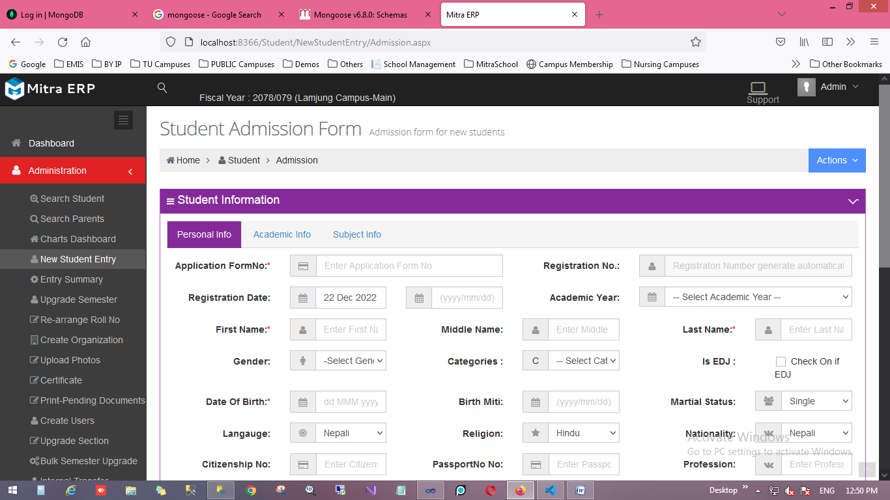

Academic Info

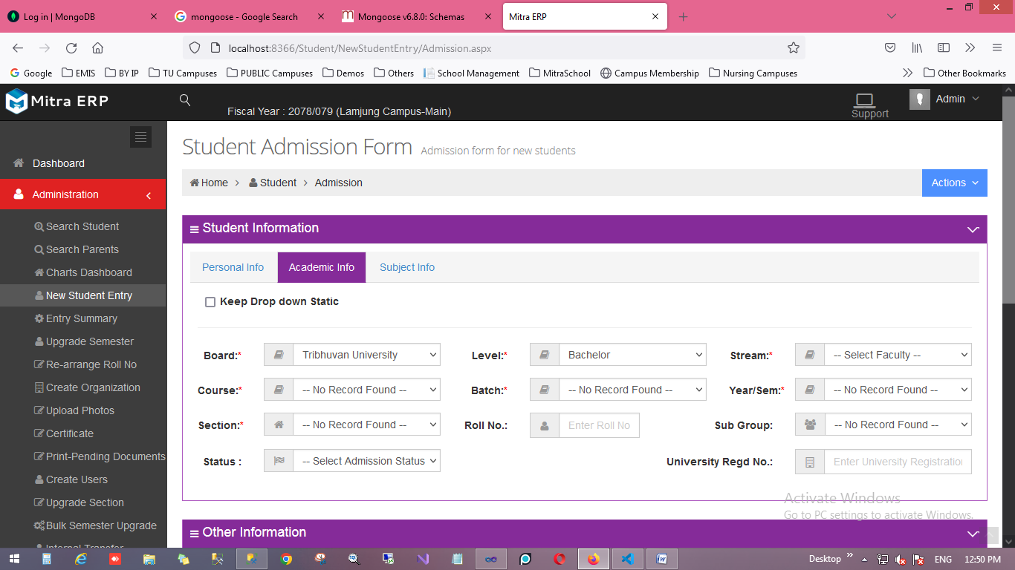

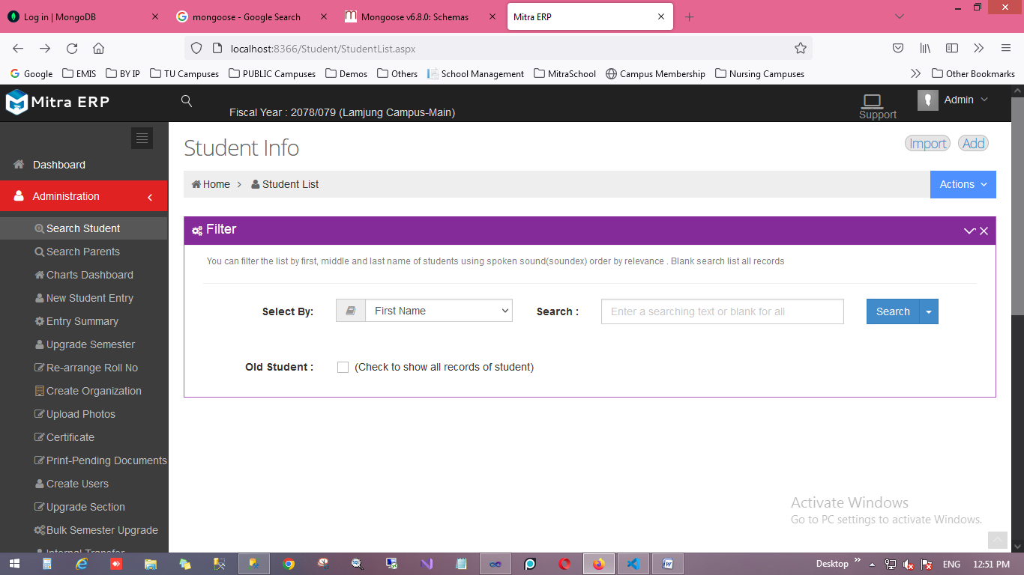Search Student

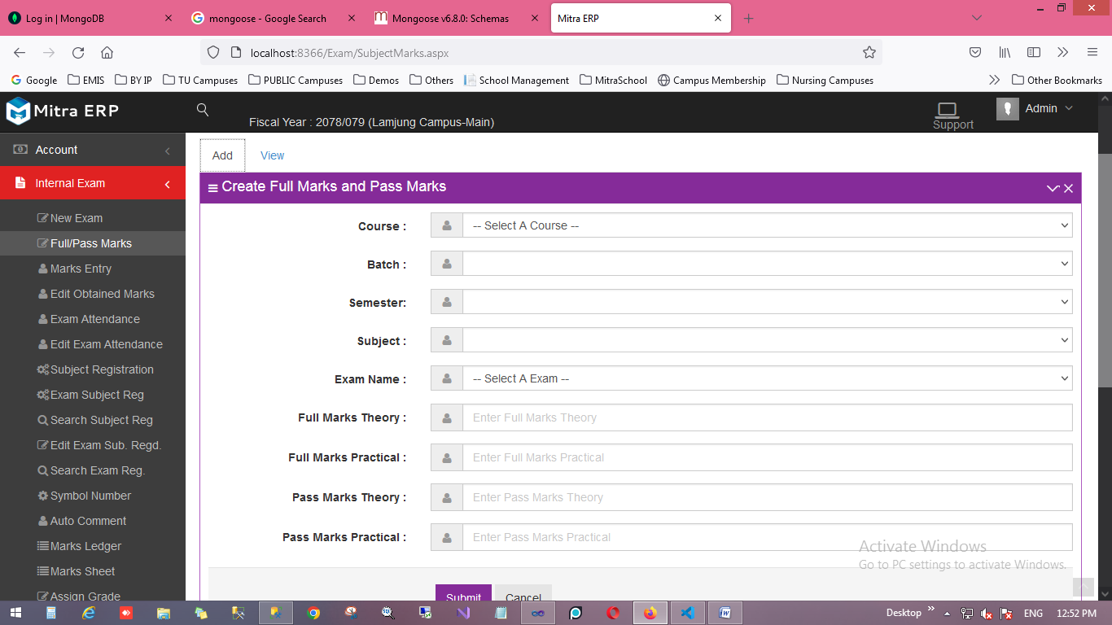Student Full Pass Marks

**# Source Code**

1 Site.Master Page

<%@ Master Language="VB" AutoEventWireup="true" CodeBehind="Site.master.vb" Inherits="School.Site" %>

<%@ Register Assembly="AjaxControlToolkit" Namespace="AjaxControlToolkit" TagPrefix="asp" %>

<!DOCTYPE html PUBLIC "-//W3C//DTD XHTML 1.0 Strict//EN" "http://www.w3.org/TR/xhtml1/DTD/xhtml1-strict.dtd">

<html xmlns="http://www.w3.org/1999/xhtml" xml:lang="en">

<head runat="server">

<meta charset="utf-8" />

<meta http-equiv="X-UA-Compatible" content="IE=edge">

<meta content="width=device-width, initial-scale=1.0" name="viewport" />

<meta content="" name="description" />

<meta content="" name="author" />

<meta name="MobileOptimized" content="320">

<link rel="shortcut icon" href="favicon.ico" />

<link href="/assets/css/themes/default.css" rel="stylesheet" type="text/css" id="style_color" />

<link href="/assets/css/custom.css" rel="stylesheet" type="text/css" />

<link href="/assets/jquery-ui-1.11.1/jquery-ui.css" rel="stylesheet" type="text/css" />

<link href="/assets/css/bootstrapValidator.css" rel="stylesheet" type="text/css" />

<link href="/assets/css/bootstrapValidator.css" rel="stylesheet" type="text/css" />

<script src="/assets/plugins/bootstrap/js/bootstrap.min.js" type="text/javascript"></script>

<script src="/assets/plugins/bootstrap-hover-dropdown/twitter-bootstrap-hover-dropdown.min.js"

type="text/javascript"></script>

<script src="/assets/scripts/app.js" type="text/javascript"></script> <script type="text/javascript">

function PrintMessage(errorCode, message) {

var icon = errorCode == 1 ? "error" : "success";

setTimeout(function () {

swal({

title: (icon[0].toUpperCase() + icon.slice(1)) + "_________________________",

text: message,

type: icon,

showCancelButton: false,

confirmButtonColor: "#852b99",

cancelButtonColor: "#852b99",

confirmButtonText: "OK",

closeOnConfirm: true

});

</ul>

</div>

<ul class="nav navbar-nav pull-left">

<li class="dropdown user"><a href="#" class="dropdown-toggle" data-toggle="dropdown"

data-hover="dropdown" data-close-others="true"><i id="I1" runat="server" style="padding-right: 8px;">

</i><span class="username hidden-sm hidden-xs" id="showFy" runat="server">Unknown</span> </a>

</li>

</ul>

<a href="javascript:;" class="navbar-toggle" data-toggle="collapse" data-target=".navbar-collapse">

<img src="/assets/img/menu-toggler.png" alt="" />

</a>

<ul class="nav navbar-nav pull-right">

<li><a href="https://support.emis.com.np/login.php" title="Click for Support" target="_blank">

<span style="display: flex; align-items: center; flex-direction: row;" class="hidden-sm hidden-xs"><i class="fa fa-laptop hidden-xs"

style="font-size: 28px;"></i>Support</span></a> </li>

<li class="dropdown user"><a href="#" class="dropdown-toggle" data-toggle="dropdown"

data-hover="dropdown" data-close-others="true"><i id="upic" runat="server" style="padding-right: 8px;">

</i><span class="username" id="username" runat="server">Unknown</span> <i class="fa fa-angle-down">

</i></a>

<ul class="dropdown-menu">

<li><a href="/Myprofile.aspx"><i class="fa fa-user"></i>My Profile</a> </li>

<li><a data-toggle="modal" href="#portlet-password"><i class="fa fa-lock"></i>Change

Password</a> </li>

<li><a href="/logOut.aspx"><i class="fa fa-key"></i>Log Out</a> </li>

</ul>

</li>

</ul>

</div>

</div>

<div class="clearfix">

</div>

<div class="theme-panel hidden-xs hidden-sm">

<div class="toggler">

</div>

<div class="toggler-close">

</div>

<div class="theme-option">

<span>Layout</span>

<select class="layout-option form-control input-small">

<option value="fluid" selected="selected">Fluid</option>

<option value="boxed">Boxed</option>

</select>

</div>

<div class="theme-option">

<span>Header</span>

<select class="header-option form-control input-small">

<option value="fixed" selected="selected">Fixed</option>

<option value="default">Default</option>

</select>

<div class="go-top float-go-top">

<i class="fa fa-angle-up"></i>

</div>

<div class="footer">

<div class="copyright">

<div class="color-white">

<center>

2014-2021 &copy; Copyright Erasoft. All rights reserved.</center>

</div>

</div>

</div>

</div>

<script type="text/javascript">

jQuery(document).ready(function () {

App.init();

});

var pgtitle = $(".page-title").html().split("<");

$("title").text("Mitra ERP :: " + pgtitle[0]);

</script>

</form>

</body>

</html>

**# CreateSudents.aspx**

<%@ Page Title="" Language="vb" AutoEventWireup="false"MasterPageFile=

"~/Site.Master" CodeBehind="CreateStudents.aspx.vb" Inherits="School.CreateStudents" %><asp:Content ID="Content1" ContentPlaceHolderID="HeadContent" runat="server">

<title>Application New Students </title>

<script type="text/javascript">

function print(divId) {

var contents = $("#" + divId).html();

var win = window.open("", "", "height=500,width=900");

win.document.write("<link href=\"/assets/plugins/bootstrap/css/bootstrap.min.css\"

rel=\"stylesheet\" type=\"text/css\" />");

win.document.write("</head><body >");

win.document.write(contents);

win.document.write("</body></html>");

win.print();

win.close();

return true;

}

$(document).ready(function () {

$("#toExcel").click(function () {

$("#<%= btnToExcel.ClientID %>").click();

});

});

</script>

<script type="text/javascript">

$(function () {

$("#<%=txtCalendar.ClientID %>").datepicker({ dateFormat: "yy-mm-dd", changeMonth: true, changeYear: true }).val(), new Date()

});

</script>

<script type="text/javascript">

$(document).ready(function () {

$("#<%=txtCalendar.ClientID %>").datepicker({ dateFormat: "yy-mm-dd" }).datepicker("setDate", new Date());

});

</script>

</asp:Content>

<asp:Content ID="Content2" ContentPlaceHolderID="MainContent" runat="server">

<div class="page-content">

<div class="modal fade" id="portlet-config" tabindex="-1" role="dialog" aria-labelledby="myModalLabel" aria-hidden="true"><div class="modal-dialog"><div class="modal-content"><div class="modal-header"><button type="button" class="close" data-dismiss="modal" aria-hidden="true"></button><h4 class="modal-title">Modal title</h4></div>

**# CreateSudents.aspx.vb**

Imports System.Web.HttpContext

Public Class CreateStudents

Inherits System.Web.UI.Page

Private Dao As New DatabaseDao

Protected Sub Page_PreInit(ByVal sender As Object, ByVal e As System.EventArgs) Handles Me.PreInit

Dim currentUri = Request.Url.AbsolutePath

Dim pa As New PageAuthority

Dim uid As String

If (Session("userId") <> Nothing) Then

uid = Session("userID").ToString()

Else

Response.Redirect("/Logout.aspx")

End If

Dim hasRightToView = PageAuthority.IsAuthorized(uid, currentUri)

If Not hasRightToView Then

Dim redirectUrl = Request.Cookies("Redirect").Value.ToString()

Response.Redirect(redirectUrl)

UserFormActivity.SaveLog(Request.Url.AbsoluteUri, "Type = " & Request.Browser.Type & ", Name = " & Request.Browser.Browser & ", Version = " & Request.Browser.Version & ", Major Version = " & Request.Browser.MajorVersion & ", Minor Version = " & Request.Browser.MinorVersion, uid, System.Net.Dns.GetHostByName(System.Net.Dns.GetHostName()).AddressList(0).ToString(), System.Net.Dns.GetHostName(), Request.UserHostAddress, "0")

Else

UserFormActivity.SaveLog(Request.Url.AbsoluteUri, "Type = " & Request.Browser.Type & ", Name = " & Request.Browser.Browser & ", Version = " & Request.Browser.Version & ", Major Version = " & Request.Browser.MajorVersion & ", Minor Version = " & Request.Browser.MinorVersion, uid, System.Net.Dns.GetHostByName(System.Net.Dns.GetHostName()).AddressList(0).ToString(), System.Net.Dns.GetHostName(), Request.UserHostAddress, "1")

End If

End Sub

Protected Sub Page_Load(ByVal sender As Object, ByVal e As System.EventArgs) Handles Me.Load

If String.IsNullOrWhiteSpace(Session("userID")) And

String.IsNullOrWhiteSpace(Session("username")) And

String.IsNullOrWhiteSpace(Session("Role")) And

String.IsNullOrWhiteSpace(Session("Branch")) Then

Response.Redirect("/Login.aspx")

End If

End Sub

Protected Sub btnSubmit_Click(ByVal sender As Object, ByVal e As EventArgs) Handles btnSubmit.Click

Dim sql As String

Dim sb As StringBuilder = New StringBuilder("")

Try

sql = "exec [Students].[usp_PersonalInfo] @flag='i', @FirstName='" & txtFirstName.Text.ToString().Trim & "', @MiddleName='" & txtMiddleName.Text.ToString().Trim & "',@LastName='" & txtLastName.Text.ToString().Trim & "',@Gender='" & dropGender.Text.ToString().Trim & "', @DateOfBirth='" & txtCalendar.Text.ToString().Trim & "', @MaritalStatus='" & dropMartialStatus.Text.ToString().Trim & "', @Mobile='" & txtMobile.Text.ToString().Trim & "', @Phone='" & txtPhone.Text.ToString().Trim & "',@Email='" & txtEmail.Text.ToString().Trim & "', @BloodGroup='" & dropBloodGroup.Text.ToString().Trim & "',@Language='" & dropLanguageList.Value.ToString().Trim & "', @Religious='" & dropReligiousList.Value.ToString().Trim & "',@Nationality='" & txtNationality.Text.ToString().Trim & "',@CitizenshipNo='" & txtCitizenshipNo.Text.ToString().Trim & "',@PassportNo='" & txtPassportNo.Text.ToString().Trim & "'"

Dim ds As New DataSet

ds = Dao.ExecuteDataset(sql)

If ds.Tables(0).Rows.Count > 0 Then

sb.AppendLine("<div class='note note-success'>")

sb.AppendLine("<div class='close-note'>x</div>")

sb.AppendLine("<p>")

sb.AppendLine(ds.Tables(0).Rows(0).Item("mes").ToString)

sb.AppendLine("</p>")

sb.AppendLine("</div>")

message.InnerHtml = sb.ToString

End If

Catch ex As Exception

sb.AppendLine("<div class='note note-danger'>")

sb.AppendLine("<div class='close-note'>x</div>")

sb.AppendLine("<p>")

sb.AppendLine(ex.Message.ToString)

sb.AppendLine("</p>")

sb.AppendLine("</div>")

message.InnerHtml = sb.ToString

End Try

End Sub

Public Function Excel(ByVal html As String, ByVal fileName As String)

Current.Response.Clear()

Current.Response.Buffer = True

Current.Response.AddHeader("content-disposition", "attachment;filename=" & fileName.Replace(" ", "_") & ".xls")

Current.Response.Charset = ""

Current.Response.ContentType = "application/vnd.ms-excel"

Dim sw As New StringWriter()

sw.Write("<html>")

sw.Write("<head><meta http-equiv=""Content-Type"" content=""text/html"" charset=""UTF-8"" />")

sw.Write("<style>")

sw.Write("table{font-size:12pt; font-family:'Times New Roman'; border:1px; width:700px; border-collapse: collapse;}th{ border:1px solid black;}td{border:1px solid black;} .caption{ text-align:center; font-weight:bold; margin-top:50px important!; font-size: 18px; }")

sw.Write("</style>")

sw.Write("<body>")

Dim row As DataRow = (New DatabaseDao().ExecuteDataTable("SELECT top 1 Name,[Address] FROM Management.InstitutionalInfo").Rows(0))

sw.Write("<div class='row' style='clear:both'>")

sw.Write("<div style='text-align:center; font-weight:bold; font-size: 20px;'>" & row("Name").ToString() & "</div>")

sw.Write("<div style='text-align:center; font-weight:bold; font-size: 15px;'>" & row("Address").ToString() & "</div>")